Support Vector Machine based Fault

Classification in Batch Reactor Process

Mini-Project report submitted in partial fulfillment of the Requirements for the degree of

#### Master of Engineering ME (Big Data Analytics)

By

**Chaitanya Sachidanand (**231058005)

**Manthana HK (**231058012) **Ananya V Bhat (**231058029)



#### MANIPAL SCHOOL OF INFORMATION SCIENCES

**(A Constituent unit of MAHE, Manipal)**

## Acknowledgement

It is great pleasure to thank the people behind the success of this Mini-Project activity. I owe my deepest gratitude to all those who guided, inspired, and helped me to complete this project.

I would like to take this opportunity to express my gratitude and heartiest thanks to my panel members, **Prof. Mr. Arockiaraj S**, Associate Professor, Manipal School of Information Sciences for his inspirational support and guidance throughout my project period.

My heartful gratitude to **Dr Keerthana Prasad** Professor & Director Manipal School of Information Sciences for his full support and encouragement during the Mini-Project activity.

I would like to thank all sources mentioned in the references.

#### LIST OF FIGURES

|  |  |  |
| --- | --- | --- |
| **Table No** | **Figure Title** | **Page No** |
| 1 | Three perfect linear discriminative classifiers for our data | 8 |
| 2 | Visualization of “margins” within discriminative classifiers | 9 |
| 3 | A support vector machine classifier fit to the data, with margins (dashedlines) and support vectors (circles) shown | 10 |
| 4 | Block Diagram of the Falut Detection Model | 12 |
| 5 | Snapshot of the Batch Reactor Dataset | 13 |
| 6 | Snapshot of the Batch Reactor Dataset after introducing errors | 14 |
| 7 | Snapshot of the Batch Reactor Dataset as chart without errors | 14 |

**Contents**

|  |  |  |  |  |  |  |
| --- | --- | --- | --- | --- | --- | --- |
|  | | | | | | Page No |
| Acknowledgement | | | | |  | i |
| List of Figures | | | | |  | iii |
|  | | | | | | |
|  | | | | **ABSTRACT** | | 1 |
|  | | | | | | |
| **Chapter 1** | | | | **INTRODUCTION** | | 2 |
|  | | | | | | |
| **Chapter 2** | | | | **LITERATURE SURVEY** | |  |
|  | 2.1 | Fault Diagnosis of Batch Reactor Using Machine Learning | | | | 3 |
|  | 2.2 | Multiple Fault Diagnosis in Distillation Column Using Multikernel Support Vector Machine | | | | 4 |
|  | 2.3 | Big data approach to batch process monitoring: Simultaneous fault detection  and diagnosis using nonlinear support vector machine-based feature selection | | | | 5 |
|  | 2.4 | Fault Diagnosis of Batch Reactor Using Machine Learning | | | | 6 |
|  | 2.5 | Wiener-Neural-Network-Based Modeling and Validation of Generalized  Predictive Control on a Laboratory-Scale Batch Reactor | | | | 7 |
|  | | | | | | |
| **Chapter 3** | | | | **METHODOLOGY** | |  |
|  | 3.1 | Support Vector Machine | | | | 8 |
|  | 3.2 | Weight Calculation for Two Class SVM | | | | 10 |
|  | 3.3 | Weight Calculation for Multi-kernel SVM | | | | 11 |
|  | 3.4 | Working Procedure | | | | 12 |
|  | 3.5 | Dataset | | | | 13 |
|  | | | | | | |
| **Chapter 4** | | | | **RESULTS AND CONC;USION** | | **19** |
|  | | | | | | |
| **Chapter 5** | | | | **FUTURE WORK AND IMPROVEMENTS** | | **20** |
|  | | | | | | |
|  | | | **REFERENCES** | | | 21 |
|  | | | | | | |

## Abstract

Fault detection and diagnosis (FDD) in process industries is an important task for efficient process monitoring and plant safety. It is also essential for improving product quality and reducing production cost by reducing process downtime. Real-time multi scale classification of faults plays a vital role in process monitoring. However, some major issues such as high correlation, complexity, and non linearity of data are yet to be addressed. In this paper, a fault diagnosis approach based on multi- kernel support vector machines is proposed to classify the internal and external faults such as Reactor Temperature, Coolant In Temperature and Jacket Temperature in batch reactor experimental works. The dataset is generated collected from experimental works. The classification has been done by various methods such as decision tree, K-nearest neighbors, linear discriminant analysis, artificial neural network, subspace discriminant, and multi kernel support vector machine.

# Chapter 1 Introduction

Batch reactor processes are widely used in chemical and pharmaceutical industries for the production of various chemicals, pharmaceuticals, and specialty products. However, these processes are susceptible to various faults and anomalies that can lead to undesirable outcomes, such as decreased yield, product quality deviations, or even hazardous conditions. Early detection and classification of these faults are essential for timely intervention and effective process control. Support Vector Machines (SVMs) have emerged as powerful tools for fault classification in complex industrial processes. They are particularly effective in dealing with high-dimensional data, noisy data, and situations where the data might not be linearly separable. Traditional SVMs are designed to work with linearly separable data, but they can struggle with complex, nonlinear relationships. To address this limitation, researchers have developed the concept of using multiple kernels in SVMs, known as Multiple Kernel Support Vector Machine (MK-SVM). This approach's ability to handle non-linearity can lead to enhanced process understanding, early fault detection, and improved process control, ultimately contributing to safer and more efficient industrial operations.

# Chapter 2 Literature Survey

### Fault Diagnosis of Batch Reactor Using Machine Learning Methods

#### Abstract:

In this paper, support vector machine (SVM) is used to estimate the heat release of the batch reactor both normal and faulty conditions. The signature of the residual, which is obtained from the difference between nominal and estimated faulty values, characterizes the different natures of faults occurring in the batch reactor. In this paper, SVM model is used to generate the residual images. Fault classification has been done from the extracted image features.

#### Methodology:

Model based fault detection method is developed based on the assumption that the developed model is replica of the real plant dynamics. The input-output data are obtained by simulating the batch reactor with nominal operating conditions. The different faults have been introduced in the reactor through simulation by using MATLAB software. From the simulated input and output data, SVM estimator model is developed using LIBSVM toolbox.

#### Outcome:

In this paper, SVM model is used to generate the residual images. Fault classification has been done from the extracted image features. This paper is mainly focused on identifying fault classification of batch reactor from the residual features using artificial intelligent classifiers such as multilayer perceptron, radial basis function (RBF), and Bayesnet.

### Multiple Fault Diagnosis in Distillation Column Using Multikernel Support Vector Machine

#### Abstract:

In this paper, a fault diagnosis approach based on multikernel support vector machines is proposed to classify the internal and external faults such as reflux failure, change in reboiler duty, column tray upsets, and change in feed composition, flow, and temperature in a distillation column. The data set is generated using Aspen plus dynamics simulation at normal and faulty states. The classification has been done by various methods such as decision tree, Knearest neighbors, linear discriminant analysis, artificial neural network, subspace discriminant, and multikernel support vector machine.

#### Methodology:

This paper proposes the fault classification method to determine the various types of fault is distillation column. The main contribution of this work is as follows:

1. A fault diagnosis method for the distillation column is proposed on the basis of machine learning techniques.
2. A multiple kernel support vector machine (MK-SVM) is constructed for the recognition of normal and fault classes to classify the novel faults in the distillation column.

#### Outcome:

This paper proposed a diagnostic system based on multikernel support vector machines. In this work, the application of SVM is presented for fault diagnosis in the distillation column. For the specific type of faults SVM has better classification accuracy.

1. **Big data approach to batch process monitoring: Simultaneous fault detection and diagnosis using nonlinear support vector machine-based feature selection**

#### Abstract:

This paper presents a novel data-driven framework for process monitoring in batch processes. This paper have proposed to exploit high dimensional process data with nonlinear Support Vector Machine-based feature selection algorithm, where the aim is to retrieve the most informative process measurements for accurate and simultaneous fault detection and diagnosis. The proposed framework is applied to an extensive benchmark data set which includes process data describing 22,200 batches with 15 faults.

#### Methodology:

The proposed paper consists of two phases: (i) Offline phase includes the formulation of the fault and time-specific models for fault detection and diagnosis via historical signal process data where the novel optimization backed feature selection algorithm is used. (ii) Online phase monitors ongoing batches in realtime by using the fault and time-specific models. Prior to both phases, data needs to be re-organized and/or processed.

#### Outcome:

The implementation of the end-models as an online decision support tool as proposed in this paper can enable early intervention to the process to reverse the detected fault, significantly reduce the number of sensor measurements to diagnose the detected fault, and possibly guide for the optimal sensor placement. The paper have focused on training 2-class models where one can access historical and/or simulation-based process data.

## Using SVM Based Method for Equipment Fault Detection in a Thermal Power Plant

#### Abstract:

This work proposes a support vector machines (SVM) based model which integrates a dimension reduction scheme to analyze the failures of turbines in thermal power facilities. Finally, a real case from a thermal power plant is provided to evaluate the effectiveness of the proposed SVM based model.

#### Methodology:

Here first step of model is to identify the monitoring parameters which are related to turbine failure detection. The condition attributes (inputs) and the decision attribute (output) could be confirmed in step 1. Step 2 is data preparing phase. In this step, collected data should be prepared for implementing feature selection and constructing classifiers. In step 3, two feature selection techniques including correlation analysis and decision tree have been utilized to reduce dimension of input data. Next, the major task in step 4 is to build a SVM classifier including selecting kernel function, finding optimal parameter settings and training SVM. Finally here, they have used a testing data to validate the effectiveness of the built SVM classifier.

#### Outcome:

In this proposed work a real-world data from a thermal power company has been employed to evaluate the effectiveness of model. By comparing various ML algorithms, experimental results indicated the performance of the classifier of SVM model as being superior to those of BPN and LDA.

## Wiener-Neural-Network-Based Modeling and Validation of Generalized Predictive Control on a Laboratory-Scale Batch Reactor.

#### Abstract:

The first part is modeling the WNN-based batch reactor using the provided input−output data set. The input is feed given to the reactor, and the reactor temperature needs to be maintained in line with the optimal profile. The objective in this part is to train the neural network to efficiently track the nonlinear temperature profile that is provided from the data set. The second part is designing a generalized predictive controller using the data obtained from modeling the reactor to successfully track any arbitrary temperature profile.

#### Methodology:

The aim is to initially find the weights for the Wiener neural network that successfully track the temperature profile provided from the existing data set. Secondly, the weights obtained from the modeling are incorporated in the GPC to track the arbitrary set point profile. The results section is divided into two parts. First Part consists of the results obtained during the modeling of the batch reactor to satisfactorily track the data set temperature profile. Second Part, consists of the results obtained during the design of the generalized predictive controller.

#### Outcome:

In this paper advanced Back propagation algorithm. Using WNN prediction based controllers, one can be able to maintain the temperature of the reactor in a controlled manner to avoid any thermal runaway.Support Vector Machine can be used to increase the productive

outcome.

# Chapter 3 Methodology

#### 3.1 Support Vector Machine

A Support Vector Machine (SVM) is a powerful and versatile machine learning algorithm used for classification and regression tasks. It is particularly well-suited for classification problems and is known for its ability to handle both linear and non-linear data.

**Binary Classification:** SVM is primarily used for binary classification problems, where the goal is to separate data points into one of two classes. However, it can be extended to handle multi-class classification as well.

**Hyperplane:** At the core of SVM is the concept of a hyperplane, which is a multidimensional surface that separates data points from different classes. In a two-dimensional space, a hyperplane is a straight line, while in higher dimensions, it's a hyperplane.

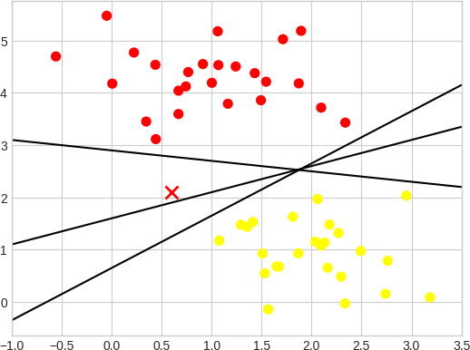

* 1. Three perfect linear discriminative classifiers for our data

**Margin:** SVM aims to find the hyperplane that maximizes the margin, which is the distance between the hyperplane and the nearest data points from each class. Maximizing the margin helps improve the model's generalization to unseen data.

**Support Vectors:** Support vectors are the data points closest to the hyperplane and are the ones that have the most influence on the placement of the hyperplane. These are the points that are "supporting" the decision boundary.

**Kernel Trick:** SVM can be used for non-linear data by employing the kernel trick. This technique allows SVM to implicitly map the data into a higher-dimensional space where a linear hyperplane can effectively separate the classes. Common kernel functions include the linear kernel, polynomial kernel, and radial basis function (RBF) kernel.

**C Parameter:** SVM has a regularization parameter known as "C." It controls the trade-off between maximizing the margin and minimizing the classification error. A smaller C value encourages a wider margin but may allow for some misclassification, while a larger C value leads to a narrower margin but fewer misclassifications.

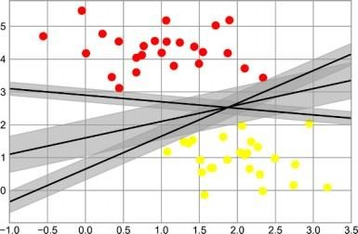

* 1. Visualization of “margins” within discriminative classifiers

Support vector machines offer one way to improve on this. The intuition is this: rather than simply drawing a zero-width line between the classes, we can draw around each line a *margin* of some width, up to the nearest point.

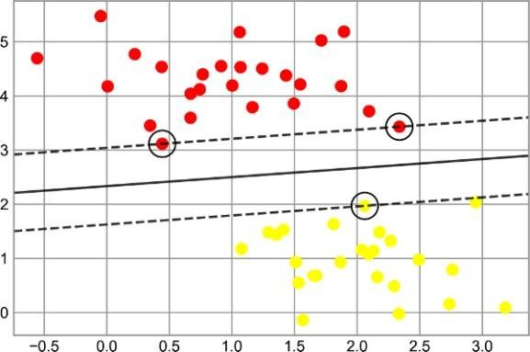

* 1. A support vector machine classifier fit to the data, with margins (dashed lines) and support vectors (circles) shown

#### 2 Weight Calculation for Two Class SVM

* + In Support Vector Machines (SVMs), the weights, denoted as w, are an important part of the model.
  + The decision boundary is the locus of points where the inner product of the feature vector x and w plus a bias term b equals zero:

**w * x + b = 0** Eq. No 1

* + Vectors that have positive f(x) are placed in one class, while vectors that have negative f(x) are placed in another class.



Eq. No 2

* + - Maximum margin can be obtained by solving the minimization problem given by

 Eq. No 3

#### Weight Calculation for Multi-kernel SVM

* + - The constrained optimization problem can be solved by using a Lagrange multiplier λi, where λi ≥ 0. This corresponds to the constraint, for a support vector. The solution can be written as minimize

Eq. No 4

* + - The optimization problem in above equation can be defined as minimize

 Eq. No 5

#### 3. 4 Working Procedure

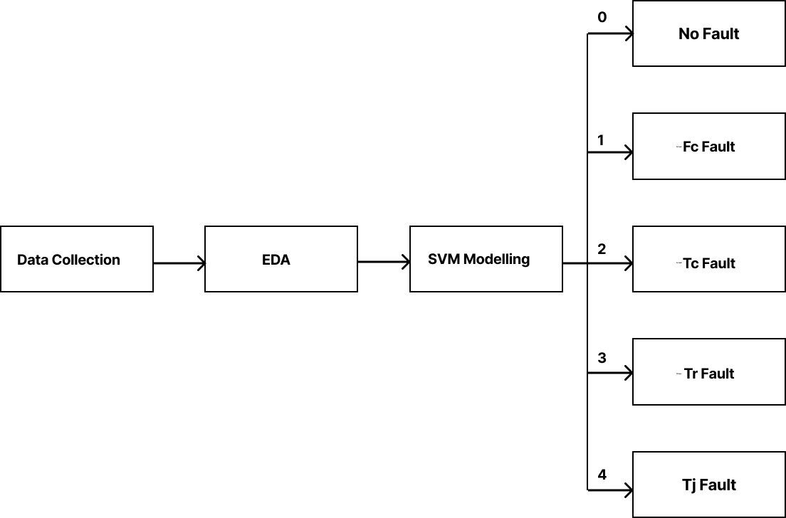

* 1. Block Diagram of the Falut Detection Model
* Collection of dataset from Batch Reactor process, which includes major attributes like actuator data, temperature of the coolant, temperature of the reactor and temperature jacket (outcome).
* Fault diagnosis model is built using the MK-SVM algorithm.
* Model has to detect the fault (temperature attributes) introduced in the Batch Reactor process.
* Upon detecting these faults, the model will generate visual plots that clearly depict the temperature variations and anomalies, allowing for easy identification and analysis.

#### Dataset

* The dataset contains informations from all sensors used in the experimental setup
* In which we are using only data which help in performing fault classification
* Features which are used are:

1. Current
2. Fc
3. Tc
4. Tr
5. Tj

* Using this data we are introducing introducing error in interval of time in data showing fault
* Based on which new labeling feature called Error specifying where error is present has been put where errors are present .

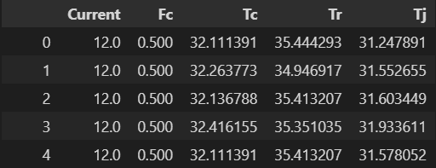

* 1. Snapshot of the Batch Reactor Dataset
  + We have manually simulated and introduced errors in certain intervals of time to generate faulty data needed for fault classification.
  + When there is no error present in the sensor the ‘Error’ will be 0 as seen in data snapshot and visual representation of data when no errors are present.

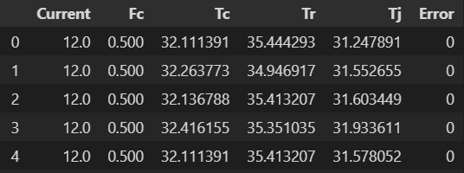

* 1. Snapshot of the Batch Reactor Dataset after introducing errors

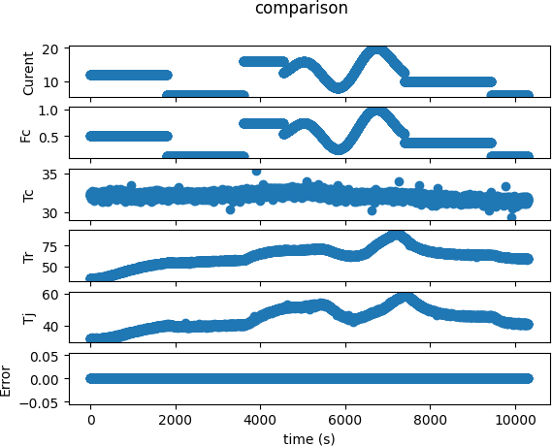

* 1. Snapshot of the Batch Reactor Dataset as chart without errors
  + When we introduce error in Fc (Flow Control)

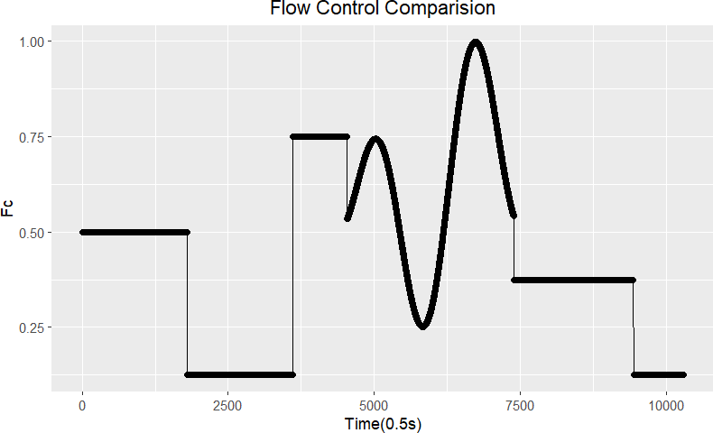

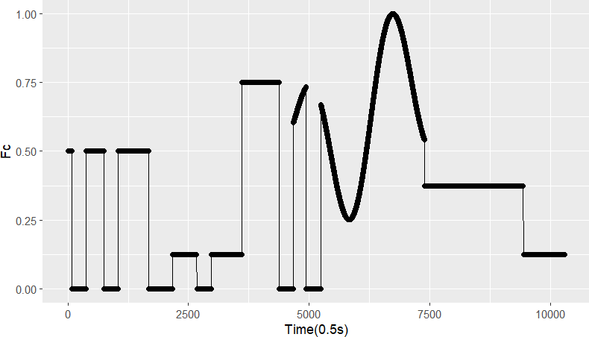

* + When we introduce error in Tc (Coolant Temperature -Inlet)

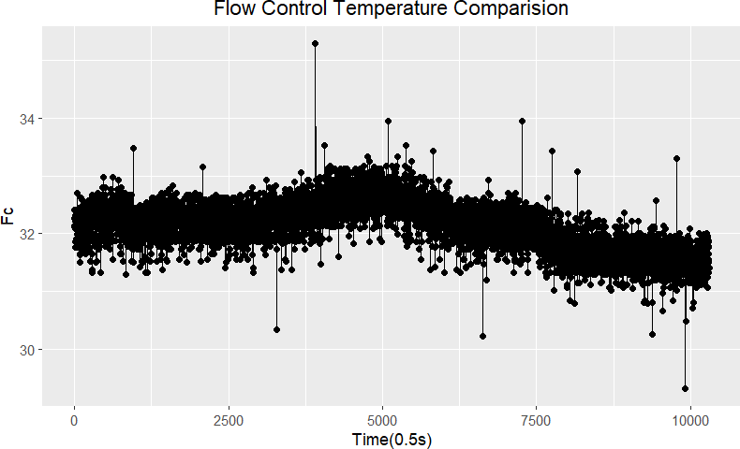

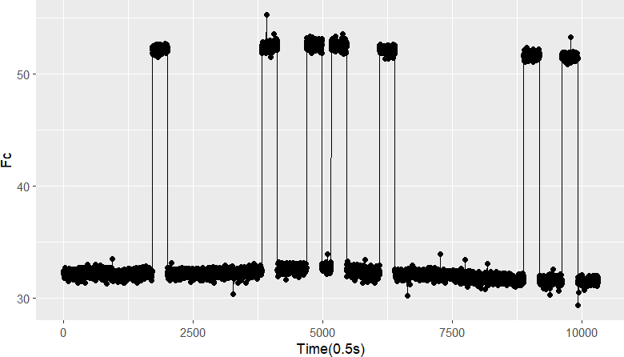

* + When we introduce error in Tr (Reactor Temperature)

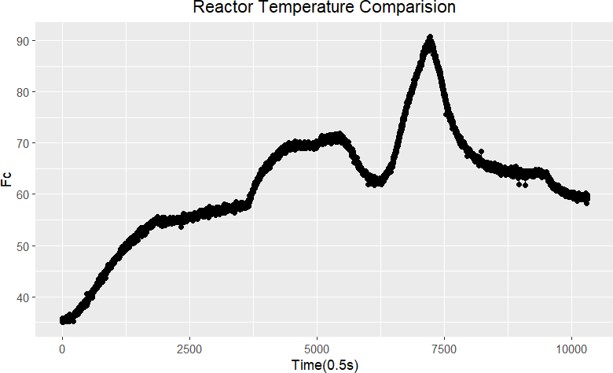

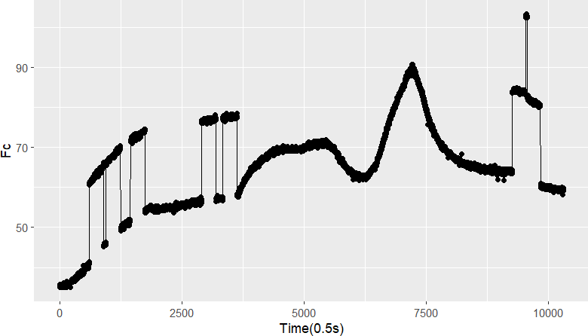

* + When we introduce error in Tj (JacketTemperature)

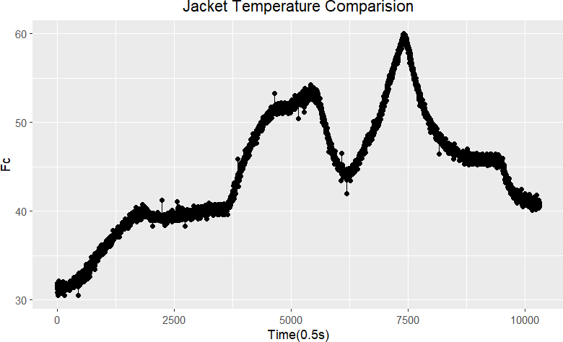

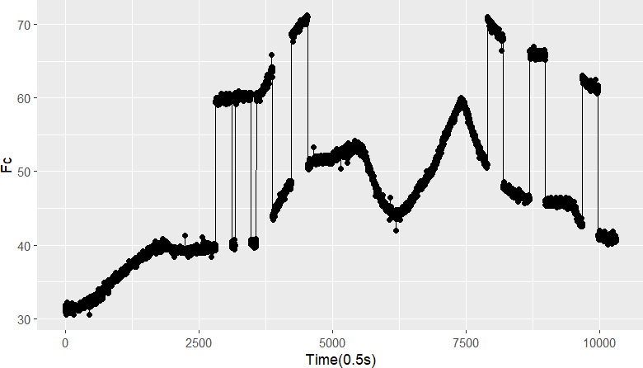

# Chapter 4 Results and Conclusion

* We confirmed and verified that for the batch reactor process fault classification the best suited Machine Learning algorithm is SVM Classifier(Support Vector Machines classification).
* Weight parameters required for this model we have inferred from our data that multiclass and Nonlinear Kernel is well suited for this Project.
* The feature which we have been providing for us in data is best suited for classification of faults.
* Random generation of fault in data has been achieved in time scale interval points with labeling of the error in the predictive features.

# Chapter 5

**Future work and Improvements**

* Trial and error method of finding the best non linear kernel is yet to be tested on the faulty data.
* The optimal weights which have been calculated on paper are yet to be tested on the real time model of SVM.
* Since the data is of Time Series format we yet to test the deep learning model and verify if our data perform better in them.
* Verification of finding new other better means on generating random faulty data is to be confirmed once again.

# References

1. Nor, N. M.; Hussain, M. A.; Hassan, C. R. C. Fault diagnosis and classification framework using multi-scale classification based on kernel Fisher discriminant analysis for chemical process system. Applied Soft Computing 2017, 61, 959−972.
2. Uddin, F.; Tufa, L. D.; Taqvi, S. A. System Behavior and

Predictive Controller Performance near Azeotropic Region. Chem. Eng.Technol. 2018, 806−818.

1. Taqvi, S. A.; Tufa, L. D.; Muhadizir, S. Optimization and

dynamics of distillation column using Aspen Plus®. Procedia Eng. 2016, 148, 978−984.

1. Taqvi, S. A.; Tufa, L. D.; Zabiri, H.; Mahadzir, S.; Maulud, A. S.; Uddin, F. Rigorous dynamic modelling and identification of distillation column using Aspen Plus; 8th Control and System Graduate Research Colloquium (ICSGRC); IEEE: 2017; pp 262−267.